KEYAZ CONSULTANCY
MIDTERM II EXAMINATION 2023
Age Group (3 – 4 years): BABY CLASS
Learning Area 4: Mathematical Concepts

My name is __________________________________________
- Match the same and write.
0 4 4
3 2 ______
1 5 ______
4 3 ______
5 0 ______
2 1 _______

- Copy and write.
6 | 7 | 8 | 9 | 10
- Circle the correct number.
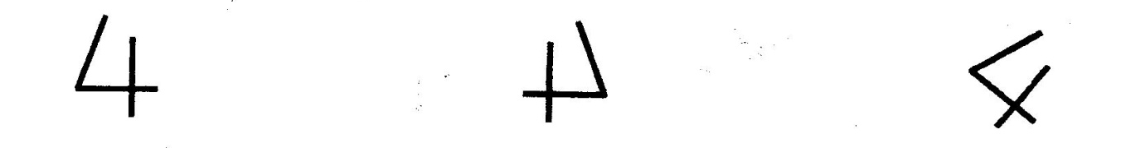

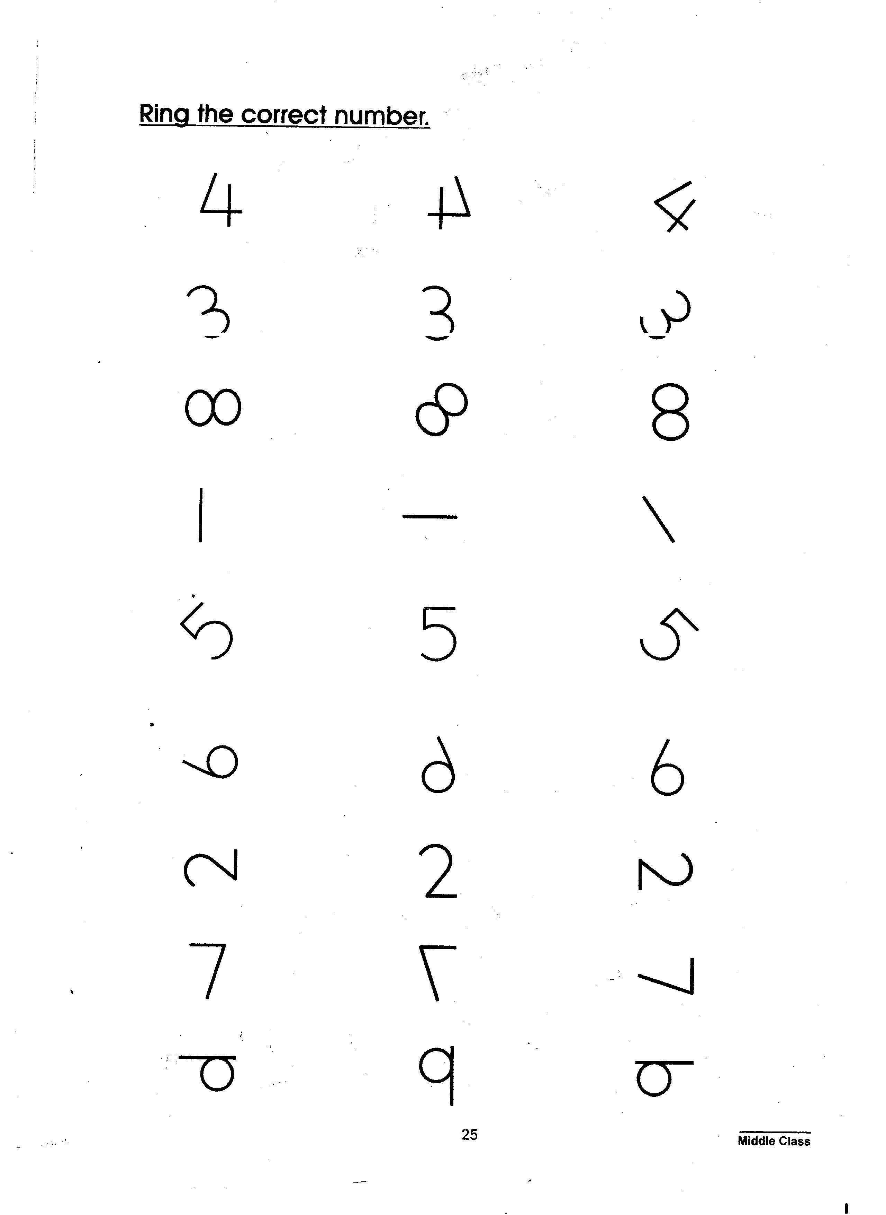

- Count and match.
4

3

6
- Count and write.

= _____________

= ______________

= ______________

End

